**Exercise 2: Verifying Interactions**

**Scenario:**

You need to ensure that a method is called with specific arguments.

**Code:**

1. **ExternalApiTest.java**

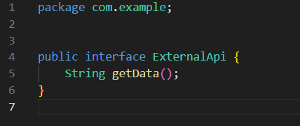

1. **MyService.java**

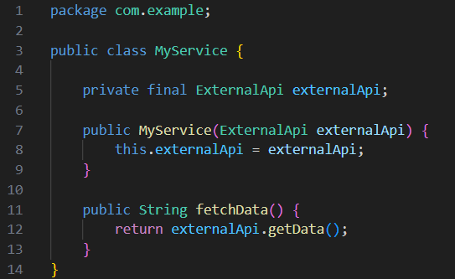

1. **MyServiceTest.java**

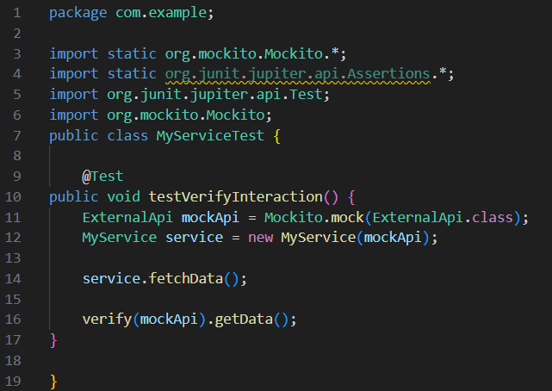

**Output:**

